Anushka shrotriya
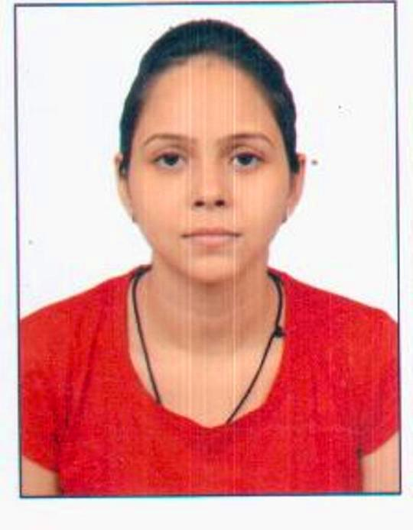
E-mail: anushkashrotriya05@gmail.com
Mob: 8823848274

Career Objective:

To be a part of an organization where get a chance to use my technical and analytical knowledge and skills to contribute in the progress of the organization as well as my personal growth.

Academic Profile:

Qualifications | Specialization | Board/Univ. | Year | CGPA/%age
M.Tech | Biotechnology | MITS, Gwalior | Pursuing 2013-15 | 7.20
B.Tech | Biotechnology | Amity Univ. | 2012 | 6.50
XII | PCB | M.P board | 2006 | 67.8%
X | Science,maths,social-studies,English | M.P board | 2004 | 82%

Technical Skill Set:

- Basic microbiological techniques: Different kinds of media preparation, (Like LB, M9, MS), methods of inoculation, different plating methods, Isolation of specific bacterial species, maintenance of primary culture and secondary culture of microbial species.
- Basic molecular biology techniques: Cloning, polymerase chain reaction, DNA isolation from plants or blood or bacterial species, DNA purification, plasmid isolation, preparation of competent cells, transformation, protein expression, protein purification by metal affinity chromatography, dialysis.
- Basic biochemical techniques: Gel electrophoresis(AGE/PAGE), pH adjustment, ultrasonication, harvesting cells by centrifugation technique, spectrophotometeric analysis using visible and UV light, Fluorescence spectrophotometer, size exclusion chromatography, metal affinity chromatography.
- Basic techniques with tissue culture: Media preparation with plant growth regulators, sterilization of ex-plants and its inoculation to the media, callus and embryo culture.

Instrumentation handling:

- Gel Documentation system.
- Centrifuge.
- UV/Visible Spectroscopy.
- PCR.
- Vertical and Horizontal Electrophoresis.
- Ultra sonicator.
- SDS PAGE.
- Fluorescence spectrophotometer.
- FPLC (Fast protein Liquid chromatography).

Projects & Training Details:

- Summer Project on protein profiling of the blood of gall bladder cancer patient from Cancer hospital and research centre Gwalior (M.P).
- One month training has been done from CIMAP Lucknow (U.P) in biotechnology and bioinformatics principles.
- Summer project on water quality control test from different samples of water by using chemical and biochemical test from Regional Food Research & Analysis Centre (RFRAC), Lucknow (U.P).
- One month training on Thermal Cycler (PCR), Gel Documentation, UV-Vis Spectrophotometer (Nano-Drop), High Speed Analytical Centrifuge, Vertical and Horizontal Electrophoresis and other minor instruments for performing molecular studies like identification of microbes using 16 S rRNA and microbial studies like Sole Source Carbon Utilization from Centre of excellence in biotechnology, MPCST, Bhopal(M.P)
- Six month M.tech final dissertation has been done in Subcloning of D100N mutant of VcPth & Expresssion and Purification of peptidyl t.RNA hydrolase of Shigella boydii in Molecular and structural department, CSIR-CDRI , Lucknow (U.P).
- Attended one day symposium on “Drug Discovery in India: past, present and future” organized by CSIR-CDRI Lucknow(U.P) .
- Attended 2 day international pharmaceutical conference-2015 on “Nanoformulations and Translational Research : Small Getting Bigger” organized by Babasaheb Bhimrao Ambedkar University, Lucknow(U.P)

Achievements:

- Secure position in GATE-2013 in Biotechnology (BT) stream.
- Qualify JAM-2014 with all India rank 167.
Key competencies:

- Quick Learner
- Proactive attitude
- Good team worker
- Good Analytical Ability
- Proficiency in English, Hindi and basic German language.

Extra-Curricular Activities:

- Participated in several cultural events at school level.
- Participated in sports activity.

Hobbies:

Listening music, gardening, cooking, reading books occasionally and dancing.

Personal Information:

Nationality : Indian
Date of Birth: 05 May 1989
Status: Unmarried
Language: Hindi, English and basic German language.
Father’s Name : Mr. Rakesh Shrotriya
Permanent Address: Shanti Sadan Ganeshpura, Morena (M.P) 476001

Declaration:

I hereby declare that above information is correct to the best of my knowledge and belief.

Place: Morena
Date: 23/08/2015

